CS-457 Digital Image Processing
Practical Task 07 Tasks:
The traditional method to implement neighborhood averaging is to perform convolution with an MxM mask of 1’s followed by a normalization by (1/M²). One way to improve the computation time is to take advantage of the fact that the neighborhood for [x+1,y] will overlap most of the neighborhood for [x,y]. Hence, we can calculate the average for pixel [x+1,y] in terms of the average for pixel [x,y] plus M pixels that are added to the right side of the [x+1,y] region, minus M pixels that are removed from the left side of the [x,y] region.

- Create an 11x11 image and sequentially fill pixel values from 1 to 121 (i.e. first pixel is gray value 1, second pixel is gray value 2 and so on.)

Code :

import numpy as np

# Create an 11x11 image with sequential pixel values
image = np.arange(1, 122).reshape(11, 11)
print("11x11 Image:\n", image)

Output:

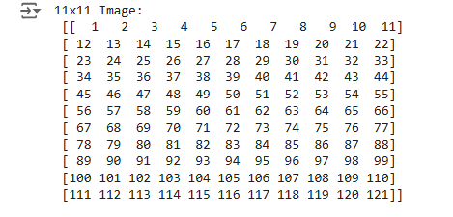

Code:

def traditional_averaging(image, mask_size):
import numpy as np

pad_size = mask_size // 2
padded_image = np.pad(image, ((0, 0), (pad_size, pad_size)), mode='constant', constant_values=0)
center_row = padded_image[5, :] # Center row (zero-padded)

output_row = []
operation_count = {'additions': 0, 'multiplications': 0, 'divisions': 0}

for i in range(len(image[0])):
# Extract the window
window = center_row[i:i + mask_size]
# Perform averaging
sum_pixels = sum(window)
operation_count['additions'] += mask_size - 1
average = sum_pixels / (mask_size ** 2)
operation_count['divisions'] += 1
output_row.append(average)

return np.array(output_row), operation_count

image = np.arange(1, 122).reshape(11, 11)
output, operations = traditional_averaging(image, mask_size=5)
print("Output Row (Traditional):", output)
print("Operations (Traditional):", operations)

Output:

- Now implement the code to perform the traditional averaging only for the center row with a 5x5 mask of 1’s and count the number of operations required in terms of additions, subtractions, multiplications, and divisions. Zero pad the image accordingly. Display the output array as well. e) Repeat step d, but with the optimized averaging approach.

Code:

def optimized_averaging(image, mask_size):
import numpy as np

pad_size = mask_size // 2
padded_image = np.pad(image, ((0, 0), (pad_size, pad_size)), mode='constant', constant_values=0)
center_row = padded_image[5, :] # Center row (zero-padded)

output_row = []
operation_count = {'additions': 0, 'subtractions': 0, 'divisions': 0}

# Calculate the first window
window = center_row[:mask_size]
sum_pixels = sum(window)
operation_count['additions'] += mask_size - 1
output_row.append(sum_pixels / (mask_size ** 2))
operation_count['divisions'] += 1

# Slide the window across
for i in range(1, len(image[0])):
sum_pixels += center_row[i + mask_size - 1] - center_row[i - 1]
operation_count['additions'] += 1
operation_count['subtractions'] += 1
average = sum_pixels / (mask_size ** 2)
operation_count['divisions'] += 1
output_row.append(average)

return np.array(output_row), operation_count

output_optimized, operations_optimized = optimized_averaging(image, mask_size=5)
print("Output Row (Optimized):", output_optimized)
print("Operations (Optimized):", operations_optimized)

Output:

